# 7)Aim:Basic Spring Boot Application with Spring Data JPA Description:

In this experiment, we will create a Spring Boot application that connects to a MySQL database and uses Spring Data JPA to perform basic database operations. The application will allow inserting and retrieving student records through a RESTful API.

* **Student.java** – The entity class representing students.
* **StudentRepository.java** – The JPA repository interface for database operations.
* **StudentController.java** – REST controller for handling HTTP requests.
* **StudentApplication.java** – Main application class for bootstrapping the application.
* **application.properties** – Configuration file for database and server.
* **pom.xml** – Maven configuration file for dependencies.

**Program:**

# LabExp7Application.java

package com.example;

import org.springframework.boot.CommandLineRunner; import org.springframework.boot.SpringApplication;

import org.springframework.boot.autoconfigure.SpringBootApplication; import org.springframework.context.annotation.Bean; @SpringBootApplication

public class LabExp7Application { public static void main(String[] args) {

SpringApplication.*run*(LabExp7Application.class, args);

}

@Bean

CommandLineRunner initDatabase(StudentRepository repo) { return args -> {

repo.save(new Student(1, "Aditya")); repo.save(new Student(2, "Chandu")); repo.save(new Student(3, "Jaggu"));

System.*out*.println("Students inserted!");

};

}

}

# Student.java

package com.example;

//import org.springframework.data.annotation.Id; import jakarta.persistence.Entity;

import jakarta.persistence.Id; @Entity

public class Student {

@Id

private int sno; //primary key private String sname; //Student name

public Student() {}

public Student(int sno, String sname) { this.sno = sno;

this.sname = sname;

}

public int getSno() {

return sno;

}

public void setSno(int sno) { this.sno = sno;

}

public String getSname() { return sname;

}

public void setSname(String sname) { this.sname = sname;

}

}

# application.properties

spring.application.name=LabExp7 server.port= 8520

spring.datasource.url=jdbc:mysql://localhost:3306/mca spring.datasource.username=root spring.datasource.password= Aditya@123 spring.jpa.hibernate.ddl-auto=create-drop spring.jpa.show-sql=true

# StudentController.java

package com.example; import java.util.List;

import org.springframework.web.bind.annotation.GetMapping; import org.springframework.web.bind.annotation.PostMapping; import org.springframework.web.bind.annotation.RequestMapping; import org.springframework.web.bind.annotation.RestController; @RestController

//@RequestMapping("/students") public class StudentController {

private final StudentRepository repo;

public StudentController(StudentRepository repo) { this.repo = repo;

}

//@RequestMapping("/students")

// Add new student @PostMapping

public Student addStudent(@RequestBody Student student) { return repo.save(student);

}

// Get all students @GetMapping

public List<Student> getAllStudents() { return repo.findAll();

}

}

# StudentRepository.java (Interface)

package com.example;

import org.springframework.data.jpa.repository.JpaRepository;

public interface StudentRepository extends JpaRepository<Student,Integer> {

}

# pom.xml

<?xml version="1.0" encoding="UTF-8"?>

<project xm[lns="http://maven.apache.org/POM/4.0.0"](http://maven.apache.org/POM/4.0.0) xmlns:xsi=["http://www.w3.org/2001/XMLSchema-instance](http://www.w3.org/2001/XMLSchema-instance)"

xsi:schemaLocation=["http://maven.apache.org/POM/4.0.0](http://maven.apache.org/POM/4.0.0) https://maven.apache.org/xsd/maven-4.0.0.xsd">

<modelVersion>4.0.0</modelVersion>

<parent>

<groupId>org.springframework.boot</groupId>

<artifactId>spring-boot-starter-parent</artifactId>

<version>3.5.6</version>

<relativePath/> <!-- lookup parent from repository -->

</parent>

<groupId>com.example</groupId>

<artifactId>StudentApplication</artifactId>

<version>0.0.1-SNAPSHOT</version>

<name>Student</name>

<description>Demo project for Spring Boot</description>

<url/>

<licenses>

<license/>

</licenses>

<developers>

<developer/>

</developers>

<scm>

<connection/>

<developerConnection/>

<tag/>

<url/>

</scm>

<properties>

<java.version>17</java.version>

</properties>

<dependencies>

<dependency>

<groupId>org.springframework.boot</groupId>

<artifactId>spring-boot-starter-data-jdbc</artifactId>

</dependency>

<dependency>

<groupId>org.springframework.boot</groupId>

<artifactId>spring-boot-starter-web</artifactId>

</dependency>

<dependency>

<groupId>com.mysql</groupId>

<artifactId>mysql-connector-j</artifactId>

<scope>runtime</scope>

</dependency>

<dependency>

<groupId>org.springframework.boot</groupId>

<artifactId>spring-boot-starter-test</artifactId>

<scope>test</scope>

</dependency>

<dependency>

<groupId>org.springframework.boot</groupId>

<artifactId>spring-boot-starter-data-jpa</artifactId>

</dependency>

</dependencies>

<build>

<plugins>

<plugin>

<groupId>org.springframework.boot</groupId>

<artifactId>spring-boot-maven-plugin</artifactId>

</plugin>

</plugins>

</build>

</project>

# Output:

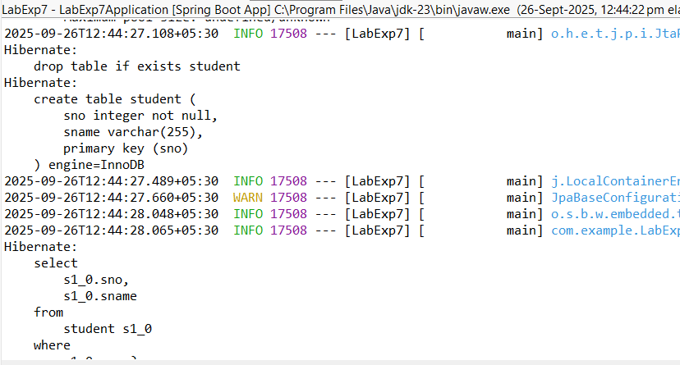

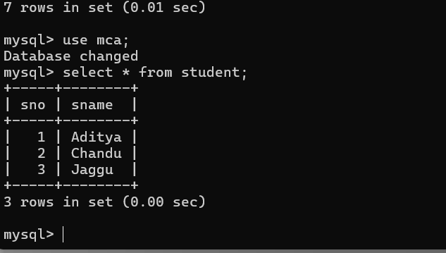

**8)Aim:Pagination and Sorting in Spring Data JPA Description:**

In this experiment, we will create a Spring Boot application that demonstrates how to paginate and sort database records using Spring Data JPA. We will use a Book entity with sample data, a JPA repository interface for database operations, and a REST controller to handle requests. Pagination parameters (page, size) and sorting parameters (sortBy, direction) will be passed via URL query parameters to retrieve data in a paginated and sorted manner.

# Program:

1. **application.properties**

spring.application.name=LabExp8

spring.datasource.url=jdbc:mysql://localhost:3306/new

spring.datasource.username=root

spring.datasource.password=Aditya@123

spring.jpa.hibernate.ddl-auto=create-drop

spring.jpa.show-sql=true

server.port=8840

# LabExp8Application.java

package com.example;

import org.springframework.boot.SpringApplication;

import org.springframework.boot.autoconfigure.SpringBootApplication;

@SpringBootApplication

public class LabExp8Application {

public static void main(String[] args) { SpringApplication.run(LabExp8Application.class, args);

}

}

# 3)Book.java

# package com.example;

# import jakarta.persistence.Entity;

# import jakarta.persistence.GeneratedValue;

# import jakarta.persistence.GenerationType;

# import jakarta.persistence.Id;

# @Entity

public class Book { @Id

@GeneratedValue(strategy = GenerationType.*IDENTITY*) private long id;

private String title; private String author;

public Book(String title, String author) { this.title = title;

this.author = author;

}

@Override

public String toString() {

return "Book [id=" + id + ", title=" + title + ", author=" + author + "]";

}

//getter and setter methods public String getTitle() { return title;

}

public void setTitle(String title) { this.title = title;

}

public String getAuthor() { return author;

}

public void setAuthor(String author) { this.author = author;

}

}

# 4)BookRepository (Interface)

package com.example;

import org.springframework.data.jpa.repository.JpaRepository;

public interface BookRepository extends JpaRepository<Book,Long>{

}

# 5)BookController.java

package com.example;

import org.springframework.beans.factory.annotation.Autowired; import org.springframework.data.domain.Page;

import org.springframework.data.domain.PageRequest;

import org.springframework.web.bind.annotation.RestController;

import org.springframework.data.domain.Pageable;

import org.springframework.data.domain.Sort; @RestController @RequestMapping("/books")

public class BookController { @Autowired

private BookRepository bookRepository;

// Insert sample data if empty @GetMapping("/init") public String initData() {

**if**(bookRepository.count()==0) {

bookRepository.save(**new** Book("Spring Boot Basics","john")); bookRepository.save(**new** Book("Java Programming","Alice")); bookRepository.save(**new** Book("Hibernate in Action","Bob")); bookRepository.save(**new** Book("Microservices Guide","Carol")); bookRepository.save(**new** Book("Data Structures","Davidraj"));

}

**return** "Sample book Added!";

}

Pagination + Sorting end point @GetMapping

public Page<Book> getBooks( @RequestParam(defaultValue = "0") int page, @RequestParam(defaultValue = "3") int size, @RequestParam(defaultValue = "title") String sortBy, @RequestParam(defaultValue = "asc") String direction

){

Sort sort = direction.equalsIgnoreCase("asc") ?

Sort.*by*(sortBy).ascending() : Sort.*by*(sortBy).descending() ;

Pageable pageable = PageRequest.*of*(page, size, sort); return bookRepository.findAll(pageable);}

}

# 6)pom.xml

<?xml version="1.0" encoding="UTF-8"?>

<project xmlns=["http://maven.apache.org/POM/4.0.0"](http://maven.apache.org/POM/4.0.0) xmlns:xs[i="http://www.w3.org/2001/XMLSchema-instance](http://www.w3.org/2001/XMLSchema-instance)" xsi:schemaLocation=["http://maven.apache.org/POM/4.0.0](http://maven.apache.org/POM/4.0.0)

https://maven.apache.org/xsd/maven-4.0.0.xsd">

<modelVersion>4.0.0</modelVersion>

<parent>

<groupId>org.springframework.boot</groupId>

<artifactId>spring-boot-starter-parent</artifactId>

<version>3.5.6</version>

<relativePath/> <!-- lookup parent from repository -->

</parent>

<groupId>com</groupId>

<artifactId>PaginationandSortingApplication</artifactId>

<version>0.0.1-SNAPSHOT</version>

<name>Book</name>

<description>Demo project for Spring Boot</description>

<licenses>

<license/>

</licenses>

<developers>

<developer/>

</developers>

<scm>

<connection/>

<developerConnection/>

<tag/>

<url/>

</scm>

<properties>

<java.version>21</java.version>

</properties>

<dependencies>

<dependency>

<groupId>org.springframework.boot</groupId>

<artifactId>spring-boot-starter-data-jdbc</artifactId>

</dependency>

<dependency>

<groupId>org.springframework.boot</groupId>

<artifactId>spring-boot-starter-web</artifactId>

</dependency>

<dependency>

<groupId>com.mysql</groupId>

<artifactId>mysql-connector-j</artifactId>

<scope>runtime</scope>

</dependency>

<dependency>

<groupId>org.springframework.boot</groupId>

<artifactId>spring-boot-starter-test</artifactId>

<scope>test</scope>

</dependency>

<dependency>

<groupId>org.springframework.boot</groupId>

<artifactId>spring-boot-starter-data-jpa</artifactId>

</dependency>

</dependencies>

<build>

<plugins>

<plugin>

<groupId>org.springframework.boot</groupId>

<artifactId>spring-boot-maven-plugin</artifactId>

</plugin>

</plugins>

</build>

</project>

# Output:

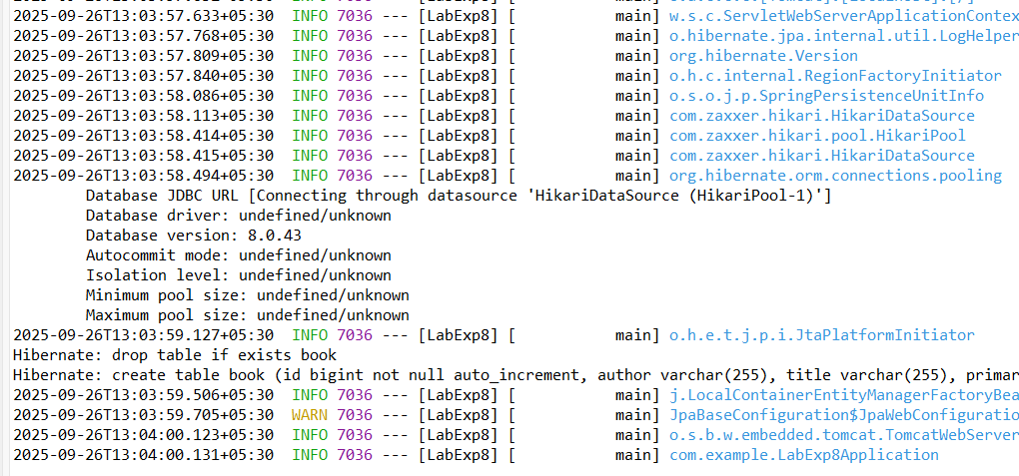

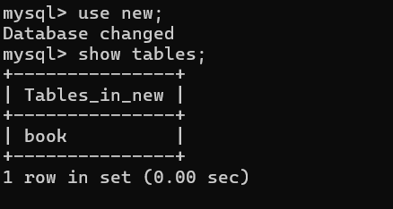

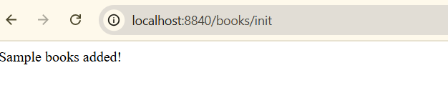

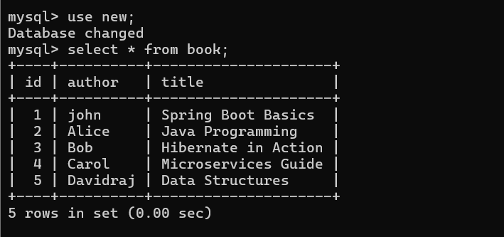

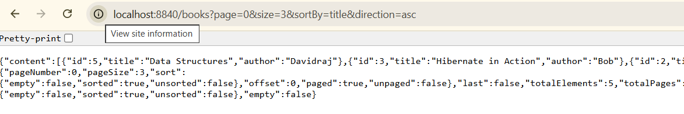

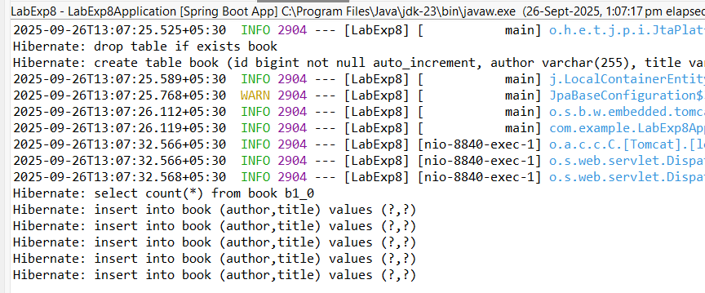

**9)Aim:Implementing AOP for Logging with Spring Data JPA Description:**

In this experiment, we create a Spring Boot application to manage products. The application includes:

* **Entity** – Product with id, name, and price.
* **Repository** – ProductRepository for database operations.
* **Service** – ProductService to handle business logic.
* **Controller** – ProductController for REST APIs.
* **Aspect** – LoggingAspect to log method calls in ProductService.
* **Database** – H2 in-memory DB or MySQL.
* **Dependency Management** – Managed via Maven (pom.xml).

This demonstrates the use of **Spring Data JPA**, **Spring AOP**, and **RESTful API development**.

# Program:

1. **ProductRepository.java (Interface)**

package com.example;

import org.springframework.data.jpa.repository.JpaRepository;

public interface ProductRepository extends JpaRepository<Product, Long> {

}

# ProductService.java

package com.example;

import org.springframework.stereotype.Service; import java.util.List;

@Service

public class ProductService {

private final ProductRepository repo;

public ProductService(ProductRepository repo) { this.repo = repo;

}

public Product saveProduct(Product product) { return repo.save(product);

}

public List<Product> getAllProducts() { return repo.findAll();

}

}

# application.properties

spring.application.name=LabExp9 spring.datasource.url=jdbc:mysql://localhost:3306/mca spring.datasource.username=root spring.datasource.password=Aditya@123 spring.jpa.hibernate.ddl-auto=create-drop spring.jpa.show-sql=true

server.port=6677

# ProductController.java

package com.example;

import org.springframework.web.bind.annotation.*; import java.util.List;

@RestController @RequestMapping("/products") public class ProductController {

private final ProductService service;

public ProductController(ProductService service) { this.service = service;

}

@PostMapping("/add")

public Product addProduct(@RequestBody Product product) { return service.saveProduct(product);

}

@GetMapping("/all")

public List<Product> getAllProducts() { return service.getAllProducts();

}

}

# product.java

package com.example;

import jakarta.persistence.Entity;

import jakarta.persistence.GeneratedValue; import jakarta.persistence.GenerationType; import jakarta.persistence.Id;

@Entity

public class Product { @Id

@GeneratedValue(strategy = GenerationType.*IDENTITY*) private long id;

private String name; private double price;

public Product() {}

public Product(String name, double price) { this.name = name;

this.price = price;

}

// getters & setters

public Long getId() { return id; }

public void setId(Long id) { this.id = id; } public String getName() { return name; }

public void setName(String name) { this.name = name; } public double getPrice() { return price; }

public void setPrice(double price) { this.price = price; }

}

# LoggingAspect.java

package com.example;

import org.aspectj.lang.JoinPoint;

import org.aspectj.lang.annotation.Aspect; import org.aspectj.lang.annotation.Before;

import org.springframework.stereotype.Component; @Aspect

@Component

public class LoggingAspect {

// Logs before executing any ProductService method @Before("execution(* com.example.demo.ProductService.*(..))") public void logBefore(JoinPoint joinPoint) {

System.out.println(">>> Entering method: " + joinPoint.getSignature().getName());}

}

# main.java

package com.example;

import org.springframework.boot.CommandLineRunner; import org.springframework.boot.SpringApplication;

import org.springframework.boot.autoconfigure.SpringBootApplication; import org.springframework.context.annotation.Bean;

@SpringBootApplication

public class LabExp9Application {

public static void main(String[] args) { SpringApplication.*run*(LabExp9Application.class, args);

}

@Bean

CommandLineRunner runner(ProductRepository repo) { return args -> {

repo.save(new Product("Laptop", 55000));

repo.save(new Product("Mobile", 20000));

repo.save(new Product("Tablet", 30000));

repo.save(new Product("Mouse", 35000));

};

}

}

# pom.xml

<?xml version="1.0" encoding="UTF-8"?>

<project xm[lns="http://maven.apache.org/POM/4.0.0"](http://maven.apache.org/POM/4.0.0) xmlns:xs[i="http://www.w3.org/2001/XMLSchema-instance](http://www.w3.org/2001/XMLSchema-instance)"

xsi:schemaLocation=["http://maven.apache.org/POM/4.0.0](http://maven.apache.org/POM/4.0.0) https://maven.apache.org/xsd/maven-4.0.0.xsd">

<modelVersion>4.0.0</modelVersion>

<parent>

<groupId>org.springframework.boot</groupId>

<artifactId>spring-boot-starter-parent</artifactId>

<version>3.5.4</version>

<relativePath/> <!-- lookup parent from repository -->

</parent>

<groupId>com</groupId>

<artifactId>productApplication</artifactId>

<version>0.0.1-SNAPSHOT</version>

<name>product</name>

<description>Demo project for Spring Boot</description>

<url/>

<licenses>

<license/>

</licenses>

<developers>

<developer/>

</developers>

<scm>

<connection/>

<developerConnection/>

<tag/>

<url/>

</scm>

<properties>

<java.version>21</java.version>

</properties>

<dependencies>

<dependency>

<groupId>org.springframework.boot</groupId>

<artifactId>spring-boot-starter-data-jdbc</artifactId>

</dependency>

<dependency>

<groupId>org.springframework.boot</groupId>

<artifactId>spring-boot-starter-web</artifactId>

</dependency>

<dependency>

<groupId>com.mysql</groupId>

<artifactId>mysql-connector-j</artifactId>

<scope>runtime</scope>

</dependency>

<dependency>

<groupId>org.springframework.boot</groupId>

<artifactId>spring-boot-starter-test</artifactId>

<scope>test</scope>

</dependency>

<!-- Spring AOP -->

<dependency>

<groupId>org.springframework.boot</groupId>

<artifactId>spring-boot-starter-aop</artifactId>

</dependency>

<!-- Lombok (optional, just to reduce boilerplate) -->

<dependency>

<groupId>org.projectlombok</groupId>

<artifactId>lombok</artifactId>

<optional>true</optional>

</dependency>

<dependency>

<groupId>org.springframework.boot</groupId>

<artifactId>spring-boot-starter-data-jpa</artifactId>

</dependency>

<!-- H2 Database (in-memory, no need for MySQL setup) -->

<dependency>

<groupId>com.h2database</groupId>

<artifactId>h2</artifactId>

<scope>runtime</scope>

</dependency>

</dependencies>

<build>

<plugins>

<plugin>

<groupId>org.springframework.boot</groupId>

<artifactId>spring-boot-maven-plugin</artifactId>

</plugin>

</plugins>

</build>

</project>

**Output:**

